Name: ___________________________________________ Date: ________________________

Neuron Notes

Types of Neurons:
- Different neurons have different functions, and might need different shapes to perform those functions
- Sensory neurons carry information from the sense organs to the spinal cord and brain (CNS)
- Motor neurons carry information from the brain or spinal cord to muscles, organs, or glands.
- Interneurons connect sensory and motor neurons

Neuron:

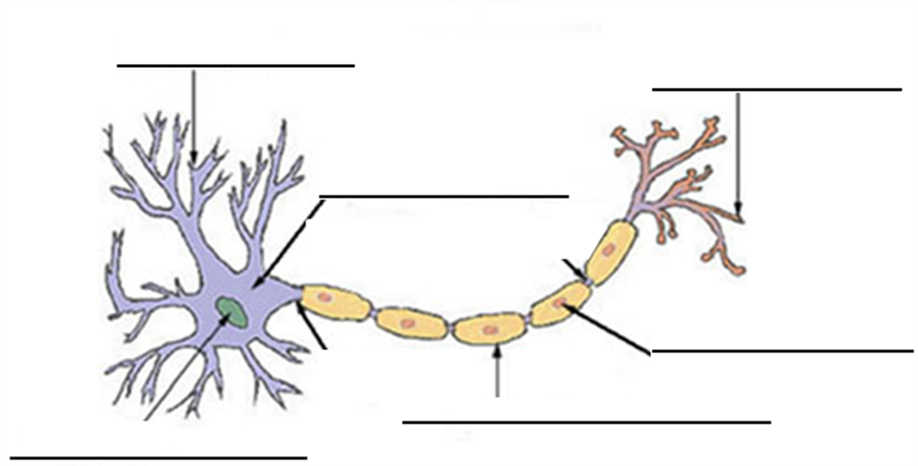

- Dendrites:
  - Dendrites are the thin extensions that spread out from the cell body.
  - Dendrites receive information from the external environment or other neurons (either in the central nervous system or interneurons)
  - Dendrites carry this information to the cell body
- Cell Body:
  - This is the largest and easiest part of the neuron to see.
  - It contains a nucleus, cytoplasm, and organelles just like other cells.
  - This is where most of the metabolic activity occurs:
    - Cellular respiration for energy
    - Protein Synthesis
    - Breaking down old organelles
- Axon:
  - The long extension of the cell body is the axon
  - Most neurons only have one axon.
  - The axon hillock (part closest to the cell body) is what generates the electrical impulse.
  - The impulse then travels down the axon towards the axon terminals

- Myelin Sheath:
  - Special cells called Schawnn cells wrap around the axon.
  - Together all of these cells form the myelin sheath.
  - The myelin sheath insulates the axon and increases the speed that the nerve impulses can travel down the axon
  - The gaps in between the Schwann cells are called nodes.
  - The electrical impulse jumps from node to node increasing speed because it does not need to travel down the entire axon length.
- Axon Terminals:
  - At the end of the axon, after the myelin sheath has ended, the axon splits up and ends with a bulbous portion called the axon terminal
  - When the nerve impulse reaches the axon terminal it causes the axon terminal to release a neurotransmitter into the synapse
  - The synapse is the gap between the axon terminals and the next cell
  - A neurotransmitter is a chemical that is used to transmit an impulse to another cell

Nerve Impulse:
- Neurons at rest (when they are not sending an impulse) have a negative charge
- This is called the resting potential of the neuron.
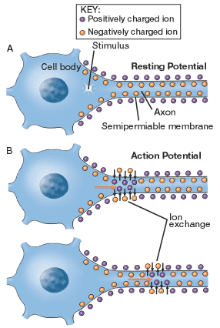
- The negative charge is created because the cell membrane of the neuron is constantly pumping positive sodium ions out of the cell
- They do this using the sodium potassium pump which is a type of active transport (it requires energy because it is making ions flow against their concentration gradient)
- The neuron’s cell membrane also contains many ion channels that do not require energy (passive transport)
- When a neuron is stimulated this causes sodium channels to open up
- Positive sodium ions flow into the cell causing it to become momentarily positive
- This triggers the sodium ions slightly farther down the axon to open creating a chain reaction
- As the cell becomes positive the potassium channels open up allowing potassium out and restoring the cell’s resting potential, but the action potential is already moving down the axon
- The action potential is the movement of the positive charge down the axon
- A nerve will only fire if the stimulus reaches that neurons threshold
- If the stimulus is any less than the threshold nothing will happen
- It does not matter if the stimulus is much stronger than the threshold, it will not make the neuron fire any more
- So, it didn’t matter how hard I whacked you with the rubber hammer, your leg would still react the same as long as I hit you hard enough to reach the threshold
- The axon terminal contains sacs of neurotransmitters
- When the positive charge reaches the axon terminal that causes the sacs of neurotransmitters to be released from the neuron into the synapse (gap between that neuron and the next cell)
- The neurotransmitters travel across the synapse to the next cell
- If that cell is a nerve cell and there are enough neurotransmitters to meet or exceed the threshold, an action potential will be generated
- If the cell is muscle it will probably contract
- If the cell is a gland it will probably release a hormone
- Different neurons contain different neurotransmitters that send the target cells different messages
- A few seconds after the neurotransmitters bind to the other cell’s surface they are released and broken down by enzymes or recycled to the axon terminal

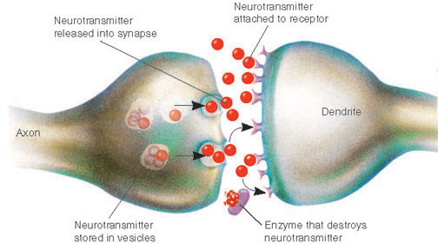

Parts of the Nervous System:
- Nerve – a bundle of different neurons
  - Sensory nerves – impulses lead to the brain or spinal cord
  - Motor nerves – impulses lead away from the brain or spinal cord
- Brain – organ made up of many interneurons that interpret impulses and send out appropriate responses to them
- Spinal cord – the major nerve pathway to and from the brain that also controls many reflexes

Name: ___________________________________________ Date: ________________________

Neuron Notes

Types of Neurons:
- Different neurons have different ______________________, and might need different shapes to perform those functions
- ____________________ neurons carry information from the ________________ organs to the spinal cord and brain (_____________)
- Motor neurons carry information _______________ the brain or spinal cord to __________________, organs, or ___________________
- Interneurons _____________________ sensory and motor neurons

Neuron:

- Dendrites:
  - Dendrites are the thin __________________________ that spread out from the cell _______________
  - Dendrites _____________________ information from the ____________________ environment or other ____________________ (either in the central nervous system or _________________________)
  - Dendrites carry this information to the _____________ _________________

- Cell Body:
  - This is the _____________________ and easiest part of the neuron to see.
  - It contains a ___________________, cytoplasm, and ______________________ just like other cells.
  - This is where most of the _______________________ activity occurs:
    - Cellular _________________________ for energy
    - __________________ Synthesis
    - Breaking down old _______________________
- Axon:
  - The _____________ extension of the cell body is the _______________
  - Most neurons only have ___________ axon.
  - The axon ____________________ (part closest to the cell _____________) is what generates the ______________________ impulse.
  - The ______________________ then travels down the axon towards the axon ______________________
- Myelin Sheath:
  - Special cells called _________________ cells wrap around the axon.
  - Together all of these cells form the ________________ ___________________
  - The myelin sheath ______________________ the axon and increases the _____________ that the nerve impulses can travel down the ______________
  - The _____________ in between the Schwann cells are called ________________
  - The electrical impulse _______________ from node to node increasing ________________ because it does not need to travel down the ________________ axon length
- Axon Terminals:
  - At the end of the axon, after the ________________ _________________ has ended, the axon ______________ up and ends with a bulbous portion called the axon _____________________
  - When the nerve ________________ reaches the axon _____________________ it causes the axon terminal to release a ______________________________ into the __________________
  - The synapse is the ____________ between the ______________ ________________________ and the next ____________
  - A neurotransmitter is a _____________________ that is used to transmit an _______________ to another cell

Nerve Impulse:
- Neurons at ______________ (when they are not sending an __________________) have a ___________________ charge
- This is called the resting ___________________ of the neuron.
- The negative charge is created because the cell ______________________ of the neuron is constantly pumping positive _______________ ions _________ of the cell
- They do this using the _________________ _____________________ pump which is a type of ___________________ transport (it requires __________________ because it is making ions flow against their _____________________ gradient)
- The neuron’s cell ___________________ also contains many ion ____________________ that do not require energy (____________________ transport)
- When a neuron is stimulated this causes sodium channels to _______________ up
- ___________________ sodium ions flow ___________ the cell causing it to become momentarily positive
- This triggers the _________________ ions slightly farther down the axon to ______________ creating a chain reaction
- As the cell becomes ___________________ the ______________________ channels open up allowing potassium out and restoring the cell’s ______________________ potential, but the action potential is already moving down the ______________
- The ________________ potential is the ____________________ of the positive charge down the axon
- A nerve will only _____________ if the stimulus reaches that neurons _______________________
- If the stimulus is any ___________ than the threshold ____________________ will happen
- It does not matter if the stimulus is much _____________________ than the threshold, it will not make the neuron fire any more
- The axon ________________________ contains sacs of ____________________________
- When the ________________ charge reaches the axon terminal that causes the _____________ of neurotransmitters to be _____________________ from the neuron into the ___________________ (gap between that neuron and the next cell)
- The neurotransmitters travel across the synapse to the next cell
- If that cell is a ________________ cell and there are enough neurotransmitters to meet or exceed the ______________________, an action potential will be generated
- If the cell is ____________________ it will probably _____________________
- If the cell is a __________________ it will probably release a hormone
- Different neurons contain ____________________ neurotransmitters that send the target cells different ______________________
- A few seconds after the neurotransmitters _____________ to the other cell’s surface they are _______________________ and broken down by ________________ or recycled to the axon terminal

Parts of the Nervous System:
- Nerve – a ___________________ of different neurons
  - Sensory nerves – impulses lead to the brain or spinal cord
  - Motor nerves – impulses lead away from the brain or spinal cord
- Brain – organ made up of many ___________________________ that interpret impulses and send out appropriate responses to them
- Spinal cord – the major _________________ pathway to and from the brain that also controls many _________________

