Elements & Macromolecules in Organisms

Most common elements in living things are carbon, hydrogen, nitrogen, and oxygen. These four elements constitute about 95% of your body weight. All compounds can be classified in two broad categories --- organic and inorganic compounds. Organic compounds are made primarily of carbon. Carbon has four outer electrons and can form four bonds. Carbon can form single bonds with another atom and also bond to other carbon molecules forming double, triple, or quadruple bonds. Organic compounds also contain hydrogen. Since hydrogen has only one electron, it can form only single bonds.
Each small organic molecule can be a unit of a large organic molecule called a macromolecule. There are four classes of macromolecules (polysaccharides or carbohydrates, triglycerides or lipids, polypeptides or proteins, and nucleic acids such as DNA & RNA). Carbohydrates and lipids are made of only carbon, hydrogen, and oxygen (CHO). Proteins are made of carbon, hydrogen, oxygen, and nitrogen (CHON). Nucleic acids such as DNA and RNA contain carbon, hydrogen, oxygen, nitrogen, and phosphorus (CHON P).
Use the drawing of the amino acid on this worksheet (look ahead to another page for this sketch and remember that the NUMBER OF LINES from a single atom is their NUMBER OF BONDS) to determine the number of bonds formed by:
___2___ Oxygen ___1____Hydrogen ____3___ Nitrogen

The body also needs trace amounts of other elements such as calcium, potassium, and sulfur for proper functioning of muscles, nerves, etc. Color each of the elements on the next page according to the color listed next to the element's symbol. Then Color code the squirrel with the correct proportion of each element's color. Now color code the carrot with the same colors as you used on the squirrel.
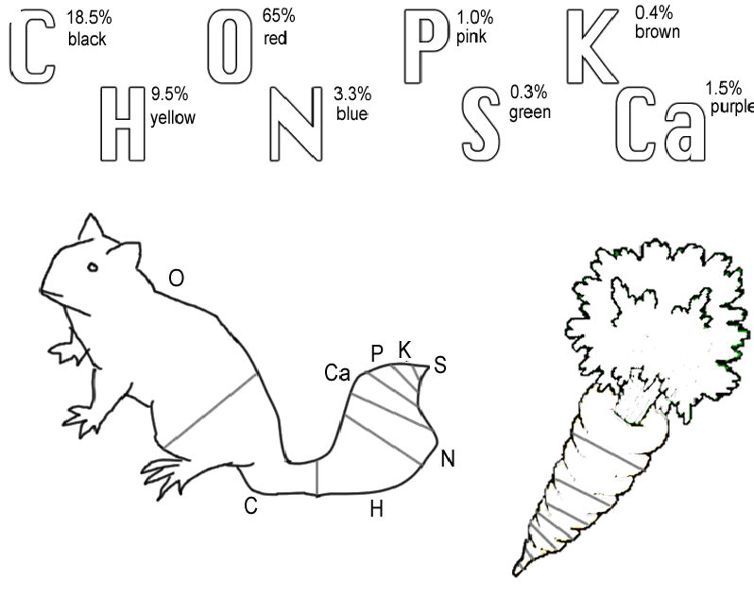

Questions:

1. Name the 4 main elements that make up 95% of an organism.

Carbon, Hydrogen, Oxygen, Nitrogen

2. Name the 4 types of bonds carbon can form.

Covalent bonds( single, double, triple,quadruple)

3. What are macromolecules?

Large molecules, large organic molecules

4. Name the 4 classes of macromolecules.

Carbohydrate, Lipids, Proteins, Nucleic Acids

5. Give 2 examples of nucleic acids. DNA RNA

6. What elements make up carbohydrates & lipids (symbols)? C H O

7. Name 3 elements your body needs trace amounts of for proper functioning. Sulfur, Potassium, Calcium, phosphorous

Use your textbook to help draw the three carbon based structures:

Straight Chain: Branched Chain: Ring:

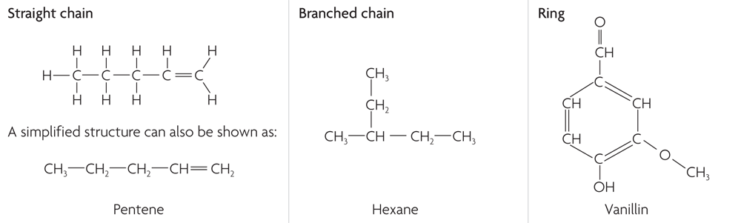

The four main classes of organic compounds (carbohydrates, lipids, proteins, and nucleic acids) that are essential to the proper functioning of all living things are known as polymers or macromolecules. All of these compounds are built primarily of carbon, hydrogen, and oxygen but in different ratios. This gives each compound different properties.

Carbohydrates are used by the body for energy and structural support in cell walls of plants and exoskeletons of insects and crustaceans. They are made of smaller subunits called monosaccharides. Monosaccharides have carbon, hydrogen, and oxygen in a 1:2:1 ratio. Monosaccharides or simple sugars include glucose, galactose, and fructose. Although their chemical formulas are the same, they have different structural formulas. These simple sugars combine to make disaccharides (double sugars like sucrose) and polysaccharides (long chains like cellulose, chitin, and glycogen).

Color code the glucose molecule on this worksheet (carbon-black, hydrogen-yellow, and oxygen-red).
Use the diagram of glucose to tell how many carbons, hydrogens, and oxygens are in a single molecule.

#C ____6_____ # H ____12______ # O _____6_____

Glucose Molecule
O
C
C
C
C
C
O
H
H
C
H
H
O
H
H
H
O
H
H
O
H
H
O
H

Questions:

8. Macromolecules are also known as ___Polymers____.

9. If all the macromolecules are made mainly of the elements CHO, how are they different? CHO are in different ratios

10. Name 2 ways your body uses carbohydrates.

Energy and structural support in cells

11. What are the subunits called that make up carbohydrates?

Carboxyl group (COOH-) and Amino group NH₃

12. What is the ratio of C, H, and O in monosaccharides? 1:2:1

13. Name 3 monosaccharides . glucose, galactose, fructose

NOTE: many sugars end in the letters -ose

14. Monosaccharides are ____simple___ sugars.

15. What are disaccharides & give an example?

Double ring sugar ---sucrose (table sugar)

16. Long chains of sugars are ____polysaccharides_____. Name three. Cellulose, chitin, glycogen, starch

Proteins are made of subunits called amino acids and are used to build cells and do much of the work inside organisms. They also act as enzymes helping to control metabolic reactions in organisms. Amino acids contain two functional groups, the carboxyl group (-COOH) and the amino group (-NH₂). The R group differs for every amino acid, organisms use 20 different amino acid, your body makes 12 of the amino acid you need.

Use your textbook and sketch the amino and carboxyl groups. (47)

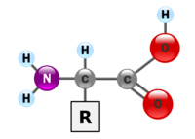

Amino group Carboxyl group

Color code the amino acid on this worksheet (carbon-black, hydrogen-yellow, nitrogen-blue, and oxygen-red). Add the R group for serine.

Basic Structure of Amino acid
N
H
H
C
C
O
H
H
R group

Enzymes are protein molecules that act as biological catalysts. Cells contain thousands of different enzymes to control the functions of the cell. Enzymes must physically fit a specific substrate(s) to work properly. The place where a substrate fits an enzyme to be catalyzed is called the active site. Excess heat, a change in pH from neutral, etc. change the shape of enzymes and their active sites so the enzyme is unable to work. Some enzymes have a second site where a coenzyme attaches to help make the substrate better fit the active site of the enzyme. Color the enzyme purple, the substrate yellow, and the coenzyme green. Also color the active site red.

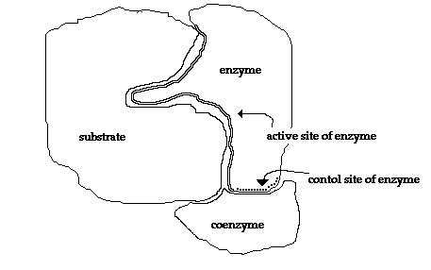

Enzyme-Substrate Complex

Condensation (removal of a water molecule) links amino acids link together to form chains called polypeptides. Polypeptide chains join to form proteins. The bonds holding amino acids to each other are known as peptide bonds. Use your textbook to make a sketch of a dipeptide (2 amino acids linked with a peptide bond) molecule. (p59)

Dipeptide Sketch:

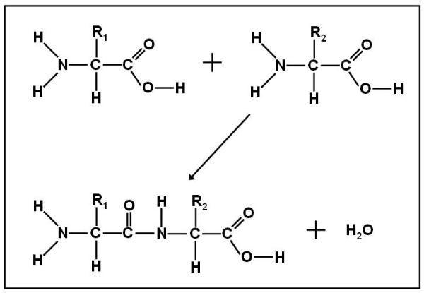

Questions:

17. What subunits make up proteins? Amino acids

18. Proteins also act as __enzymes_____ in cells to control reactions.

19. Name the 2 functional groups in amino acids.

Carboxyl group (COOH-) and amino group (NH₃)

20. Cells have _thousands__ of enzymes to act as biological __catalysts_____.

21. Enzymes have an attachment site called the ____active______ site for the _____enzyme and substrate_____ to join.

22. What is the effect of excess heat or temperature on an enzyme?

Denatures the enzyme (protein) and it will not be able to work (function)

23. Amino acids are linked together to make proteins by removing a molecule of ___water_____ in a process called _Condensation___.

24. Chains of amino acids make _______polypepitdes________ which can join together to make a _____protein_____.

25. ____Peptide______ bonds form when water is removed to hold ____amino acids_____ acids together.

Lipids are large, nonpolar (won't dissolve in water) molecules. Phospholipids make up cell membranes. Lipids also serve as waxy coverings (cuticle) on plants, pigments (chlorophyll), and steroids. Lipids have more carbon and hydrogen atoms than oxygen atoms. Fats are made of a glycerol (alcohol) and three fatty acid chains. This subunit is called a triglyceride. Color the glycerol molecule using the same colors for carbon, hydrogen, and oxygen as you did before. The fatty acid chains may be saturated (only single bonds between carbons) or unsaturated (contain at least one double bond). A carboxyl functional group (-COOH) is found on the end of the fatty acid that does NOT attach to glycerol. CIRCLE AND LABEL the carboxyl groups in the 2 fatty acids on this worksheet. Color the fatty acid chains the same colors for carbon, hydrogen, and oxygen as you did before. A special type of lipid called phospholipids help make up the cell membrane. Two layers of these phospholipids make up the membrane. Phospholipids have a "water-loving" hydrophilic head and two "water-fearing" hydrophobic tails. Find the cell membrane on this sheet and CIRCLE AND LABEL a phospholipid. Proteins are also embedded in the cell membrane. Color the two proteins in the cell membrane blue.

Glycerol
C
C
C
H
H
H
H
H
O
O
O
H
H
H

Saturated fatty Acid
H
C
C
C
C
C
C
H
C
C
C
H
H
H
H
H
H
H
H
H
H
H
H
H
H
H
H
H
C
O
O
H

Unsaturated Fatty Acid - Double Bond
H
C
C
C
C
C
C
H
C
C
C
H
H
H
H
H
H
H
H
H
H
H
H
H
H
H
H
H
C
O
O
H

Cell Membrane

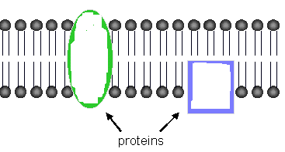

Questions:

26. Lipids are nonpolar. What does this mean? Will not dissolve in water.

27. What WILL lipids (oils and fats) dissolve in? (Question for thought) other nonpolar molecules

28. ___Phspholipids______________ makes up cell membranes.

29. Name a waxy lipid covering plants. cuticle

30. Plant pigments like ______chlorophyll______ are also ___lipids____.

31. Lipids have more ___C__ and __H___ than they do oxygen atoms.

32. Fats are made of an alcohol called glycerol and three fatty acid chains. This is known as a ______triglyceride______.

33. If there are all SINGLE bonds between ___C____ in the fatty acid chain, then it is said to be ______saturated______.

34. If there is a DOUBLE bond between ____C (or to a H)_____ in the fatty acid chain, then it is said to be __unsaturated_______.

35. The end of the fatty acid that does NOT attach to glycerol has what functional group? Write the formula for this group.

Carboxyl group—COOH-

36. ___2____ layers of _phospholipids______ make up the cell membrane.

37. The head of a phospholipid _loves_____ water and is said to be __hydrophilic________.

38. The 2 tails of a phospholipid _hates______ water and is said to be ___hydrophobic_______.

Nucleic acids carry the genetic information in a cell. DNA or deoxyribose nucleic acid contains all the instructions for making every protein needed by a living thing. RNA copies and transfers this genetic information so that proteins can be made. The subunits that make up nucleic acids are called nucleotides.

COLOR AND LABEL the parts of a nucleotide --- sugar (5-sided)-green, phosphate group (round)-yellow, and nitrogen base (6-sided)-blue. ATP used for cellular energy is a high energy nucleotide with three phosphate groups. Color code the ATP and LABEL THE PHOSPHATES.

Nucleotide
phosphate group
5C sugar
if DNA - deoxyribose
if RNA - ribose
Nitrogen base - one ring so must be a pyrimadine (cytosine, thymine or uricil)

ATP

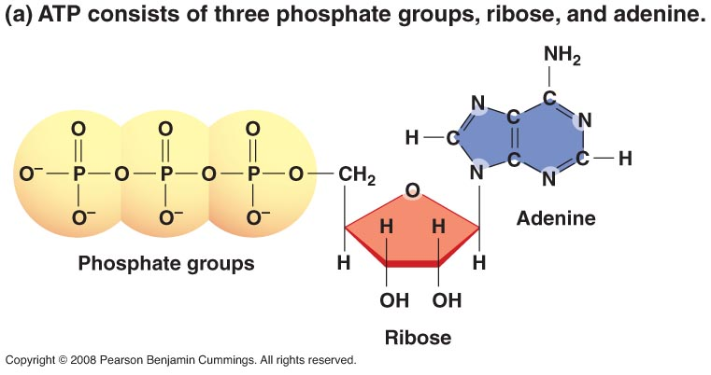
3 phosphate groups a sugar and nitrogen base

Questions:

39. Nucleic acids carry _____genetic_____ information in a molecule called _____DNA____ or __Deoxyribose____ ____Nucleic ___ acid.

40. DNA has the instructions for making a cell's _proteins________.

41. The nucleic acid ___RNA______ copies DNA so ____proteins_____ can be made.

42. _____Nucleotides_____ are the subunits making up nucleic acid.

43. The 3 parts of a nucleotide are a 5 carbon _sugar____, a phosphate, and a nitrogen _base_____.

44. ____ATP____ is a high energy molecule made from a ____nucleotide_______ with ___3____ phosphates.

Final Questions:

1. Give the symbols for the elements that make up each of the following:

__CHO_carbohydrates __CHO_lipids ___CHNOP__DNA _CHON__proteins

2. Name the 4 classes of macromolecules & give a function for each.

Carbohydrate energy and structure of cells (plant cells/walls)

Lipids energy and cell membrane

Proteins cell structure, function of cells (enzymes)

Nucleic acids DNA transmit genetic info---RNA help DNA to make proteins

3. Name the subunits that make up each of the macromolecules.

Carbohydrate--monosaccarides

Lipids --fatty acids

Proteins---amino acids

Nucleic acids --nucleotides

4. Enzymes can be denatured (unfolded) by what environmental factors?

Change in pH or heat (high temperatures)

5. What process is used to link amino acids together? Condensation reaction

6. Name the bonds found between amino acids in a polypeptide chain Peptide bonds-covalent bonds.

7. Explain the difference between a disaccharide and a polysaccharide. Give an example of each.

di-two ring sugar--sucrose

poly-many ring sugar---starch

8. What two functional groups are found in amino acids?

Amino group and carboxyl group

9. Why are enzymes important to organisms?

Controls the functions of cells

10. Name the subunit that makes up fats.

Fatty acid

11. What alcohol is found in a triglyceride?

11. What alcohol is found in a triglyceride?

Glycerol

12. What is the difference between a saturated and unsaturated fatty acid?

Saturated—solid at room temperature; like butter ; single bonds between C atoms

Unsaturated –liquid at room temperature; like peanut oil; double bonds between C or H

