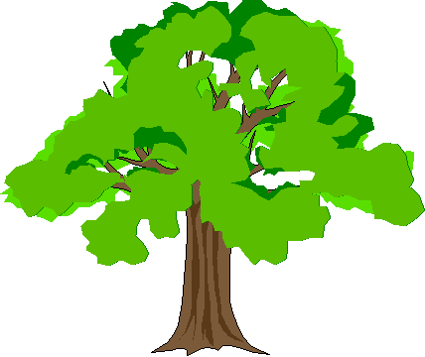
BIG TREE ELEMENTARY

Office 926-1740 Nurse 926-1741

Room #: _________________ Date: ___________________

Child’s name: ______________________________________

Parent/
Guardian:__________________________________________

Teacher: ______________________________________

( ) will be picked up at dismissal

By: ________________________________________

( ) will be picked up at ________ am/pm

By: ________________________________________

Reason: _____________________________________

( ) was absent on _____________________________

Reason: ______________________________________

______________________________________

( ) was late on ________________________________

Reason: ______________________________________

Signature: _________________________________________
Parent/Guardian

Compliments of Big Tree Elementary PTA

BIG TREE ELEMENTARY

Office 926-1740 Nurse 926-1741

Room #: _________________ Date: ___________________

Child’s name:______________________________________

Parent/
Guardian:__________________________________________

Teacher: ______________________________________

( ) will be picked up at dismissal

By: ________________________________________

( ) will be picked up at ________ am/pm

By: ________________________________________

Reason: _____________________________________

( ) was absent on _____________________________

Reason: ______________________________________

______________________________________

( ) was late on ________________________________

Reason: ______________________________________

Signature: _________________________________________
Parent/Guardian

Compliments of Big Tree Elementary PTA

