Name: ________________________________________ Period: ______

Module 1: Identity Literary Terms

CONFLICT:

Definition: _______________________________________________________________________________________

Types of conflict: ____________________________________ & _________________________________________

INTERNAL CONFLICT:

____________________ vs. ________________ - character is personally conflicted over

_____________________________ or ____________________

EXTERNAL CONFLICT:

* Person vs. _______________________ – character has problem with another character
* Person vs. _______________________ – character v. heat, tornado, avalanche, etc
* Person vs. _______________________ – character has a problem with an element of society (the law, accepted way of doing things, etc.)
* Person vs. _______________________ – character battles what seems to be an uncontrollable problem

THEME:

Definition: _______________________________________________________________________________________

_______________________________________________________________________________________

**Elements of Plot**

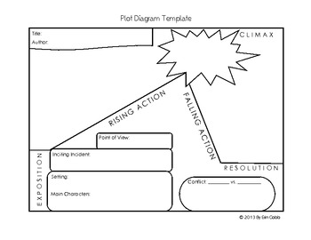

**Define the following:**

* EXPOSITION: _________________________________________________________________________________

_________________________________________________________________________________________________

* INCITING INCIDENT/CATALYST: __________________________________________________________

_________________________________________________________________________________________________

* RISING ACTION: _____________________________________________________________________________

_________________________________________________________________________________________________

* CLIMAX: ______________________________________________________________________________________

_________________________________________________________________________________________________

* FALLING ACTION: ___________________________________________________________________________

_________________________________________________________________________________________________

* RESOLUTION: ________________________________________________________________________________

_________________________________________________________________________________________________